Progress report on IUCN-WCC-2016-RES038

Yan Xie & Ruolin Miao

Xie Yan (Founder of GPAFS, xieyan@ioz.ac.cn)
Ruolin E. Miao (GPAFS Global Communication Officer, miaorl@baohudi.org)

Date: Jan. 31th, 2019

Progress Report

On the 2016 World Conservation Congress in Hawaii, a Task Force on “Protected Area Friendly System” is proposed to the World Commission of Protected Areas (WCPA). WCC-2016-Resolution 038 proposes that such task force to be established to:
- Coordinate international cooperation on PAFS theory research as well as practice, demonstration and promotion activities in a global context;
- Promote and facilitate the development of international cross-industry and cross-profession linkages between organisations, individuals and resources to conduct in-depth cooperation and information sharing;
- Initiative, promote and actively support sustainable lifestyles friendly to PAs; and
- Restore and improve integrated capacity for man and nature to live harmoniously together and to effectively preserve and enlarge PAs worldwide.

Since last progress report on the Resolution, we have been kept on promoting Protected Area Friendly (PAF) Development in China:
- Evaluating, selling, and promoting PAF products in China. GPAFS have evaluated over 50 products and over 20 of them meeting PAF criteria. All these products were sold out together over 7 million RMB.
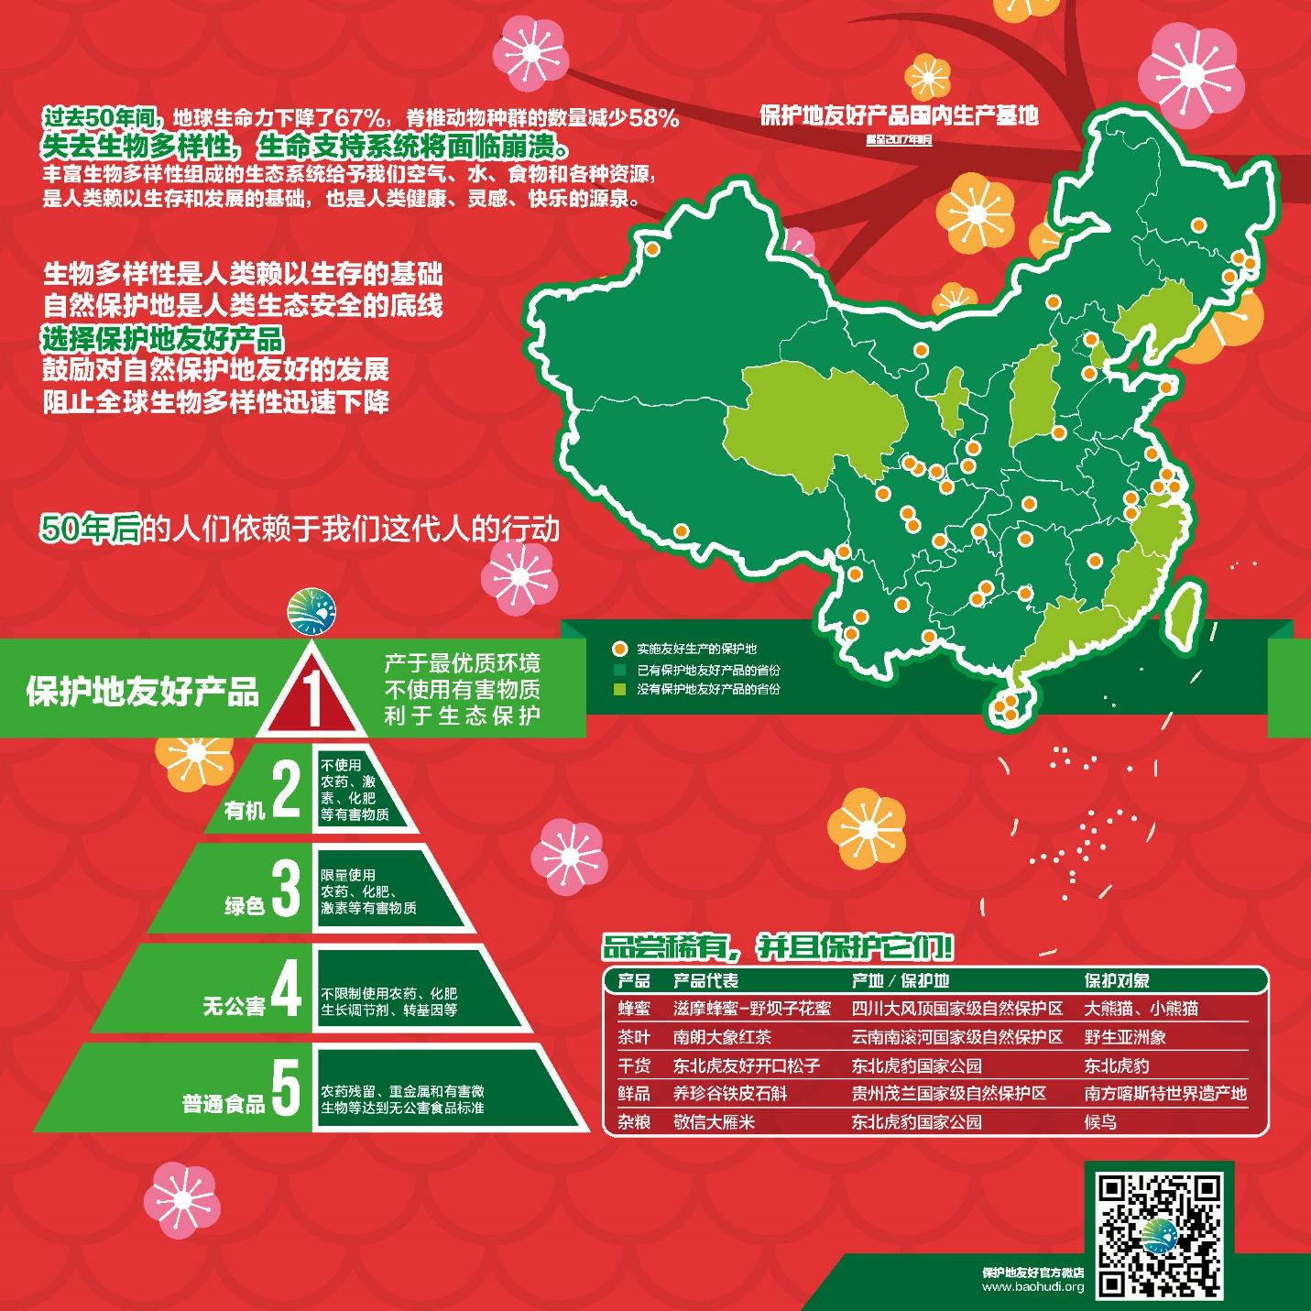

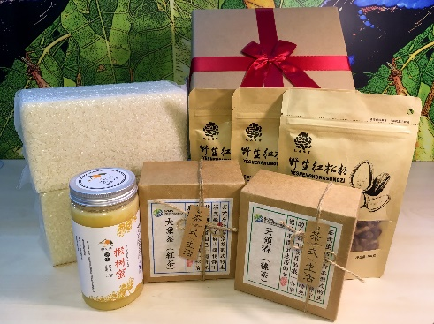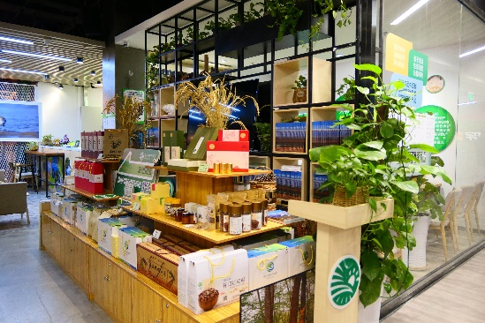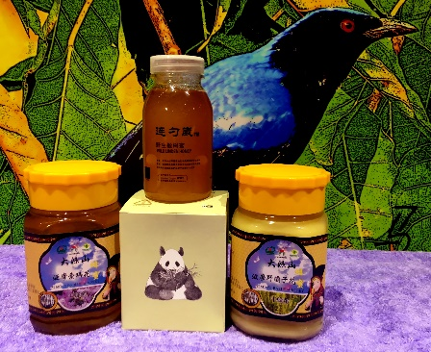

- We have also evaluated PAF products outside of China and successfully imported the first batch of the PAF products from Europe to China. It is 171kg chocolates produced by the Original Beans. It is a best practice could be promoted in China and other countries as well.
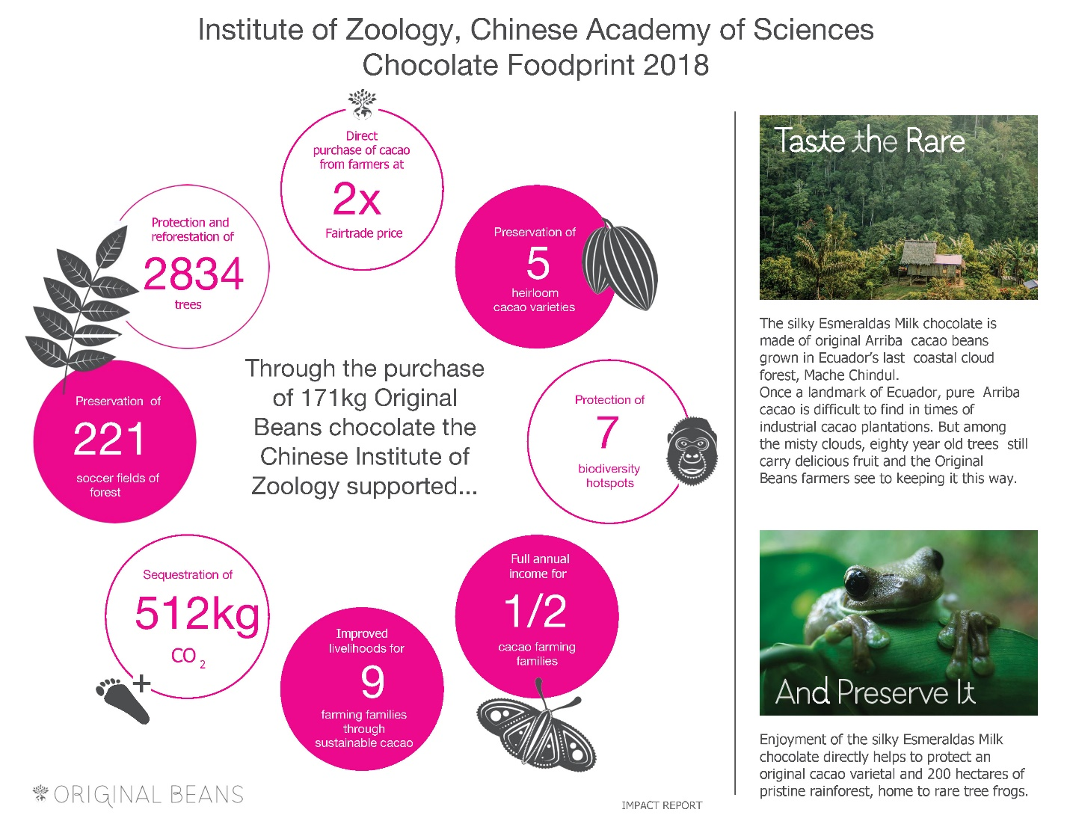
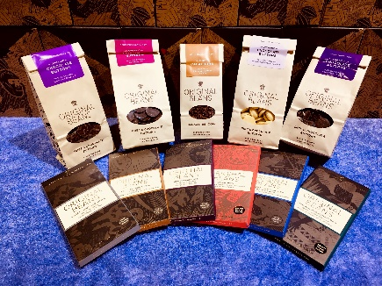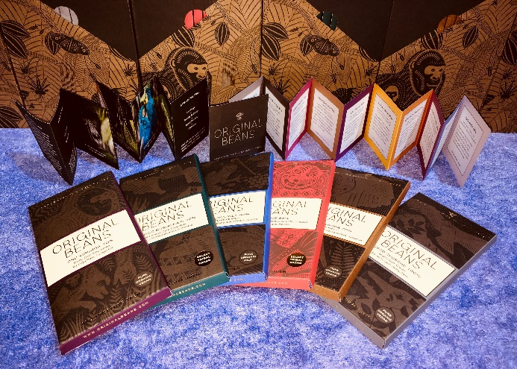
- An operation guidelines (in English and Chinese) of “Friendly Development Operation Guide for Protected Areas and their Surroundings” has been issued during the 2018 Annual Meeting of the International Alliance of Protected Areas (IAPA) in Jilin, China.
- On December 6-7th, 2018, the Workshop on Friendly Development in Protected Areas and Their Surroundings was held in Guiyang, Guizhou, China. This workshop was attended by over 160 experts, scholars, frontline staff and public, from governments, universities, scientific research institutions, enterprises, civil organizations and community around PAs. After sharing the research results and their longtime practical experiences, participants agreed that there is urgent need of promoting the Friendly Development in Protected Areas and Their Surroundings (Annex 1: Initiative to Promote Friendly Development in Protected Areas and Their Surroundings).
- Having conducted desktop researches and communicated with relevant experts by skype or during workshops, we pull together a short report on case studies on Protected Area Friendly Products and Services Around the Globe (Annex 2). While the resolution is proposed recently, the concept and practice of protected area (PA) friendly is not brand-new. In recent decades, we see many products and services being developed around the world in and around various PAs, with both development and conservation in mind. Conservationists around the world could seize this opportunity to better work with the local communities, as well as gather support from a general public with a sustainable lifestyle that supports the conservation of PAs. To further develop and expand the concept of Protected Area Friendliness, it is important to facilitate communication and cooperation among organizations and individuals who are developing PAFS products and services. We hereby summarize the state of concepts and practices related to PAFS. Note that this report does not mean to be a comprehensive overview of the state of PAF products and services, but rather we highlight some case studies and successful practices that are in our knowledge.

With in-depth research and wider communicating with practitioners, we (GPAFS) would like to call for establishment of a Task Force on ‘Protected Area Friendly System’ along with a collaborative network. This network will be important platforms for PAF providers and other organizations and individuals involved in PAF practices to share best practices and expertise, evaluate and report the conservation and economic impact of PAF products and services, and provide link to funding opportunities and international market. We should gather together to promote friendly development in protected areas and their surroundings.

Annex 1: Initiative to Promote Friendly Development in Protected Areas and Their Surroundings

December 7, 2018
Guiyang, Guizhou Province, PRC

The global ecological crisis has posed serious threats to survival and development of mankind, and protected areas (PAs) have been recognized as the most important means of responding to ecological degradation. Therefore, the Convention on Biological Diversity has set up goals of conserving and effectively managing 17% of terrestrial and inland water areas and 10% of the coastal and marine areas in the world by 2020. Considering the urgent global needs for healthy ecological environment, the PA targets of 2030 and 2050 will continue to increase, and total area of PAs will be much more than that of arable land in the world. PAs provide a good deal of important ecosystem services for the whole society, especially for the health, safety and economy of people living in and around PAs. However, various problems caused by the development in and around PAs, such as habitat loss and degradation, poaching, and pollution, pose threats to PAs.
On December 6-7th, 2018, the Workshop on Friendly Development in Protected Areas and Their Surroundings was held in Guiyang, Guizhou, China. This workshop was attended by over 160 experts, scholars, frontline staff and public, from governments, universities, scientific research institutions, enterprises, civil organizations and community around PAs. After sharing the research results and their longtime practical experiences, participants agreed that there is urgent need of promoting the Friendly Development in Protected Areas and Their Surroundings, that is, “to actively promote modes of development that are friendly to PA conservation goals, in order to alleviate the impact on PAs from developments in and around PAs.” At the same time, participants realized that to achieve and maintain the friendly development, it must be supported by governments at all levels, PA management agencies and all sectors of society.
Therefore, all the participants here jointly issued an initiative to recommend the following measures to promote friendly development in PAs and their surroundings:

- Incorporate "establishing friendly development belts of protected areas and surroundings" into the national strategy of developing ecological civilization system and the reform of the system of national parks and protected areas", to properly handle the contradiction between protected areas and their surrounding social and economic development", and to formulate corresponding guarantee mechanisms in legislation, standards, funds, policies, etc.; PA management agencies shall be given the power to supervise whether the surrounding friendly development belts meet the friendly development standards; the duty of PA management agencies shall include guiding the use of ecological compensation funds around PAs and helping community conduct friendly development; and policies such as ecological compensation, payment for ecosystem services, green finance, and ecological poverty alleviation shall be used to support the friendly development of the economic belts around PAs.
- It is recommended that local governments and PA management agencies scientifically delineate the boundary of friendly development belt, and formulate friendly development plans for each PA focusing on the conservation management goals; coordinate various resources to help local communities establish civil organizations, cooperatives and enterprises to improve self-organization ability of the communities; provide relevant concepts, technologies, capacity building, market and financial support to friendly development of local communities, leverage the traditional culture and local knowledge of communities, and foster and motivate local community to actively explore and implement various friendly development modes suitable for local environment, culture and needs.
- Through incentives from government and enterprises, such as purchase of services from civil organizations and social enterprises, civil organizations and social enterprises will become new forces of technical services for monitoring, education, ecological technology, and cultivating market docking capabilities in the friendly development belts. With social welfare in mind, social enterprises shall be supported to promote brand development, innovate eco-friendly products, and demonstrate market conversion and value addition of ecosystem service value.
- Develop an exchange platform between friendly products and enterprises, advocate the friendly product concept, set up access mechanism for friendly development, promote enterprise participation, effectively transform, increase and realize the value of ecosystem services, and support friendly development;
- Fully publicize the importance of PAs and the concept of friendly development in PAs and their surroundings, so that more and more general public (especially those who do not live close to PAs) can become a powerful society force to support and participate in conservation by purchasing and experiencing friendly products and services.

Comprehensively promoting and realizing the friendly development in PAs and their surroundings will not only facilitate the conservation goals of the PA System, but also marketize the result of conservation, i.e. the value of the ecosystem service—in this way, the people around PAs can benefit from the conservation achievements, and the general public who are far away from PAs can participate in conservation through enjoying and experiencing these products and services. In this way, we can establish a system where the whole society can support PA conservation.

Annex 2: Case Studies on Protected Area Friendly Products and Services Around the Globe

Written by: Ruolin E. Miao (GPAFS Global Communication Officer, miaorl@baohudi.org)
With feedback from Dr. Xie Yan

Date: Jan. 30th, 2019

The Protected Area Friendly (PAF) products and services typically covers four types: 1) cultivated products such as rice, tea and coffee; 2) harvested wild or semi-wild products such as honey and mushrooms; 3) artisanal products; 4) ecotourism, environmental education experience, and cultural products and services. A wide range of organizations and agencies have been involved in the production of these products, including local and international organizations, community-based enterprises, private companies, certification bodies, and PAs.

Major International Certification Bodies
There are already some widely accepted certifications that recognizes products and services that supports conservation and biodiversity. These certification bodies have had some successful cases of developing these products in and around PAs.
Rainforest Alliance
Rainforest Alliance (RA) works with three industries: agriculture, forestry and tourism. Their certifications include the Rainforest Alliance Sustainable Agriculture Standard, the Forest Stewardship Council (FSC) standard and the Rainforest Alliance’s tourism standard.
RA has projects around the globe. One example of RA’s work that is relevant to the PAFS concept is its work with community forestry in the Maya Biosphere Reserve in Guatamala. Working with the local communities, RA design “landscape-specific strategies to improve local forest business while respecting the community’s own needs and aims”. This project has diversified the timber production, and improved the competitiveness of community forest enterprises through expanding their access to finance.
Wildlife Friendly Enterprise Network
The Wildlife Friendly Enterprise Network (WFEN) grew from the system of predator-friendly ranches in western United States. WFEN focuses on certifying products that are friendly to conservation of Key Species, including keystone species, umbrella species, species defined as endangered by IUCN Red List or CITES, or species of local conservation importance. The products that are certified by WFEN as Wildlife Friendly include food, coffee and tea, spice, essential oil, fiber, tourism, jewelry, etc. These products come from North America, South America, Africa, Europe, Central Asia, and Southeast Asia. Some examples of Wildlife Friendly and Predator Friendly products are included in the following section.
Global Protected Area Friendly System
The Global Protected Area Friendly System (GPAFS) is a task force of Institute of Zoology, Chinese Academy of Sciences to bring together scientists, entrepreneurs, public organizations, and the public to support, promote and participate in new production models that are beneficial to nature conservation in and around PAs. GPAFS helps and supports PAs to improve their capacity of producing PA-friendly products and services, certifying these products that fulfill the Protected Area Friendly Standards, and provides market support to sale these products. From 2013 to 2018, GPAFS has pilot projects in 50 PAs in China (with Original Beans from 8 PAs in the tropic world) that led to the marketing of over 40 PA friendly products, most of which are food products (e.g. rice, honey, tea, wheat, wild vegetables, walnuts, chocolates, fungus, food oil, shrimps, pine nuts, dendrobium, green plum, etc.). GPAFS has developed criteria for evaluation of PAF food products. GPAFS is also promoting eco-tourism around PAs.
An example of PA friendly product is the Geese Rice produced in Jinxin Wetland Community Conservation Area, Jilin. The Geese Rice are produced in way that is both organic and friendly to the migrating geese, through eliminating the chemical fertilizers that are used in the rice paddies as well as reducing the human-wildlife conflict between the geese and the farmers. GPAFS constructs the value chain and ensures the farmers’ income. The project organizes the farmers to patrol the paddies and ensure the safety of the geese, as well as provides an additional 8% of the purchasing price to the village co-op for conservation activities.
FairWild
FairWild certifies products that are legally, sustainably collected from the wild and the processed products from these FairWild ingredients. FairWild standards address aspects including Wild Collection and Conservation Requirements, Legal and Ethical Requirements, Social and Fair Trade Requirements, and Management and Business Requirements.
Some of the collection activities certified by FairWild occur in and around PAs. A collaborative project between TRAFFIC and Bac Kan Province Forest Protection Department supports sustainable harvesting practices of medicinal and aromatic plants (MAPs) such as jiaogulan (Gynostemma pentaphyllum), in sites such as the buffer zones of Nam Xuan Lac Species and Habitat Conservation Area, Kim Hy Nature Reserve, and Ba Be National Park. The project followed the FairWild Standards as guidance for sustainable harvesting.
MAB Regional Brand
The Lima Action Plan for UNESCO’s Man and Biosphere (MAB) Programme and its World Network of Biosphere Reserves (2016-2025) pointed out the importance of effective external partnership and the role of private and social enterprises in sustainable financing of MAB reserves. Some preserves started to establish their own regional brand and trademarks. For example, the Galloway and Southern Ayrshire Biosphere Reserve in Scotland launched their own certification mark in June 2018, which will be awarded to businesses that demonstrate high standards in environmental and sustainable development. Their standards include aspects such as supporting local employment, using local services or products, environmental awareness, and energy saving practices.

Product Examples by Macro-Region
South America & Central America
In South and Central America, we see a range of community-based conservation projects producing products and services promotes the conservation of PAs. Artisanal products are a popular choice. ASOARTESANAS is a women’s artisans cooperative that works with the conservation program Proyecto Tití, which promotes the long-term preservation of cotton-top tamarin in Colombia. ASOARTESANAS operates in an area of northern Colombia which contains the last remaining population of cotton-top tamarin monkeys on the planet. The local women produce cotton-top tamarin plush toys to improve incomes as well as increase the awareness of threats posed to this endangered species. They also transform discarded plastic bags into traditional bags ("eco-mochilas").
Another type of products that are relevant to the PAF concept is non-timber forestry products from indigenous lands that are under community-based management in face of pressure from deforestation. Organización para la Defensa y Conservación Ecológica de Intag (DECOIN) is an organization that promotes conservation measures and alternative livelihoods in the Intag Valley of Ecuador, where mining is a strong environmental. The organization has created community-based forest reserves and promoted sustainable farming and eco-tourism. Other organizations in the region that are providing alternative livelihoods for indigenous communities managing their forests include Associação Terra Indígena Xingu (ATIX) and Associação Ashaninka do Rio Amônia Apiwtxa in Brazil.
North America
Some farms in the U.S. and Canada have been certified as Predator-Friendly by the Wildlife Friendly Enterprise Network. This certification recognizes that conservation of wide-ranging species such as black bear, coyote, and Florida panther does not end at the boundary of PAs. Knowing that over one-half of the U.S. land use is for agriculture WFEN target farms for reducing human-wildlife conflict through practices such as using guard dogs to protect livestock as an alternative for practices that are more harmful to predators.
Africa
Many cases of community conserved areas exist in Africa. STAGE is a project in Zimbabwe that promotes sustainable livelihoods in the Honde Valley and Nyangani Mountains, which form a major part of the Eastern Zimbabwe Mountains Endemic Bird Area. The project reduces deforestation through providing alternative livelihoods. It facilitates the production, processing, labelling and packaging of organic honey, sustainable harvesting of a bamboo species, and crafts. The ecotourism in the well-known communal wildlife conservancies in Namibia is another example of PAF service.
Asia
In Asia, we see initiatives that mitigates human-wildlife conflict in the vicinity of national parks. Jungle Organics is a company that works with the local farmers near the Jim Corbett National Park to produce Wildlife Friendly herbs and spices such as turmeric powder, ground red chili pepper, and coriander powder. Compared to conventional crops, these spices deters browsing from herbivores because of their strong taste, and brings the farmers higher revenue per unit are. These farms are unfenced to allow safe passage of wildlife, and low-tech but effective methods such as intensive foot patrols or noise making were employed by groups of farmers to reduce crop destruction. The farmers were also asked to record down the animals that passes through their farmland, creating an awareness of the role of predators to keep herbivores away.
We also see creative initiatives that uses conservation-friendly products and services to facilitate conservation of plant species. A project in the Pong Krai village in Mae Sa-Kog Ma Biosphere Reserve, Thailand, focuses on community-based conservation around Blue Vanda Orchid. The Blue Vanda (Vanda coerulea) has a rapidly declining population due to illegal harvesting and over exploitation. The local villagers obtained skill training and stems for micropropagation, as well as established a small-scale business enterprises that provides Blue Vanda products and propagation skill training services. The products use Man and Biosphere Regional Branding, and a quarter of the pricing (3 USD out of 12 USD) goes into setting up Mae Sa-Kog Ma Biosphere Reserve Foundation for further conservation activities.
Europe
Some biosphere reserves in Europe have set up their regional brands. Examples include the Galloway and Southern Ayrshire Biosphere certification trade mark mentioned before, and the regional brand “Prüfzeichen” of the Biosphere Reserve Schorfheide-Chorin in Germany.
We also see examples of high-end food products in the European market. Original Beans is a Netherland-based company that works closely with local farmers around the world to source rare and tasty cocoa beans to produce premium chocolate. For example, Original Beans source its Piura cocoa from the farmers around Bosques Secos Salitral Protected Area, a small conservation area in Peru. While the PA faces pressure of deforestation, a cocoa buffer zone has been established on one side of the PA, in between the PA and the agricultural field. Original Beans. In addition, Original Beans supported the conversion of 200 hectares of arid degraded land to cacao-agroforestry systems. The project provides fair incomes to farmers through a high and long-term fixed cacao price that is independent from the fluctuations of the international cacao price.

PAF in marine ecosystem
Concepts and practices that are related to PAF are sprouting in the marine ecosystem as well. The organization Wider Caribbean Sea Turtle Conservation Network (WIDECAST) offers trainings and publish manual to encourages private landowners such as hotels to protect sea turtle nesting beaches, and the ecotourism in turn brings the hotels benefits. In Mexico, the organization Comunidad y Biodiversidad (COBI) brings together multiple stakeholders (such as fishers, scientists and local officials) to establish fishing refuge zones, which not only increases fishers’ catch but also protects vulnerable species.

Lessons, Challenges and Opportunities
These examples of conservation-friendly products and services produced in and around PAs around the world have demonstrated that the concept and practice of PAF is replicable and expandable. Here we summarize some lessons, challenges, and opportunities that we see from these case studies.
First, involving locals and females allows the PAF production model to spread more effectively. Jungle Organics involve the local females as key stakeholders in the production, as they are often the ones in the field and the ones interacting with wildlife. These females are the “master farmers” who demonstrate the techniques of production to other farmers. In addition, involving locals and involving women also empowers these groups that are potentially marginalized in conservation projects.
Expanding consumer base and market opportunities is crucial to expanding of PAF. Consumer education is needed improve recognition of the concept of PAF and the value of PAF products and services. Some producers such as Original Beans have targeted higher-end, specialized sales channel. Others, such as WFEN, mainstream their products through collaborating with big companies such as Kering Group and Aveda. Online platform also emerges as important channels for producers to market their products. The great majority of the products sold last year through GPAFS was through the Chinese social media app WeChat, which provides easy access to people to reach online stores.
The ability to establish collaborative relationship with various stakeholders is critical for PAF providers to enhance their capacity. Local environmental civil society organizations (CSOs) could be involved in organizing the production and monitoring environmental impacts. By involving PA management agencies, PAF providers could obtain assistance in building up capacity, as well as gather policy report.
The recent emergence of sustainable financing facilities, such as the Tropical Landscapes Finance Facility in Indonesia and Sustainable India Finance Facility, provides potential funding opportunities to PAF projects. These financing facilities partner stakeholders together, and they channel loans from commercial banks to projects that are promoting sustainability or conservation.

Acknowledgement
The authors would like to like to thank the former member of GPAFS Joshua Berger for his previous research on the case studies of PAF products and services. In addition, the author wants to acknowledge the inputs from various PAF providers, who shared their experience and insights through direct communication with the author or on the 2018 Annual Meeting of the International Alliance of Protected Areas (IAPA) in Jilin, China.

Call for Information
GPAFS would like to encourage all the readers of this progress report and all its members and partners to share experiences and insights on the state of PAF products and services. Documents can be sent to Ruolin E. Miao at miaorl@baohudi.org and can provide information about various topics related to PA-friendly products and services: case studies, production standards, market intelligence, or other analyses (e.g. on products & services classification, etc.).

Xie Y, McNeely J. MacKinnon J, Miao RL, Tian DX, Gong ZL, Shi JS, Yang WH, Wang Q, Zhang YB, Berger J (eds.). Issued in 2018 and updated in Sept. 2018. Friendly Development Operation Guide for Protected Areas and their Surroundings. IAPA, Beijing, China. Available from http://www.iapa.pub (Accessed in Feb. 2019).

