Flood Relief to Indigenous Women

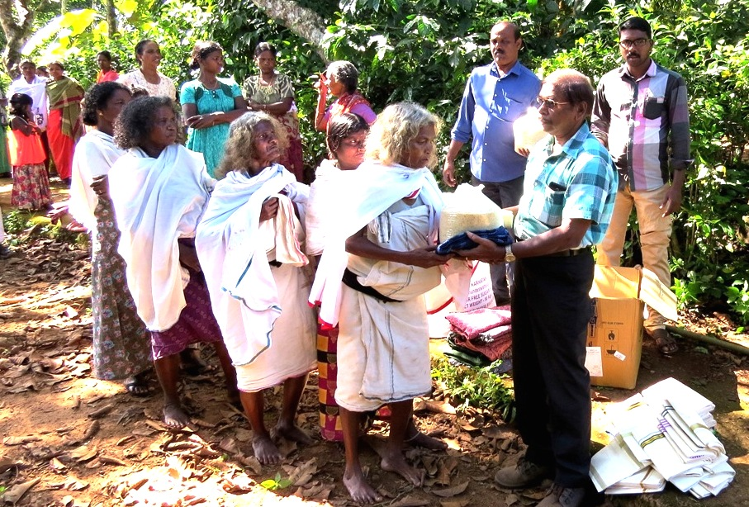

Honey Bee Day-Wild Bee Conservation

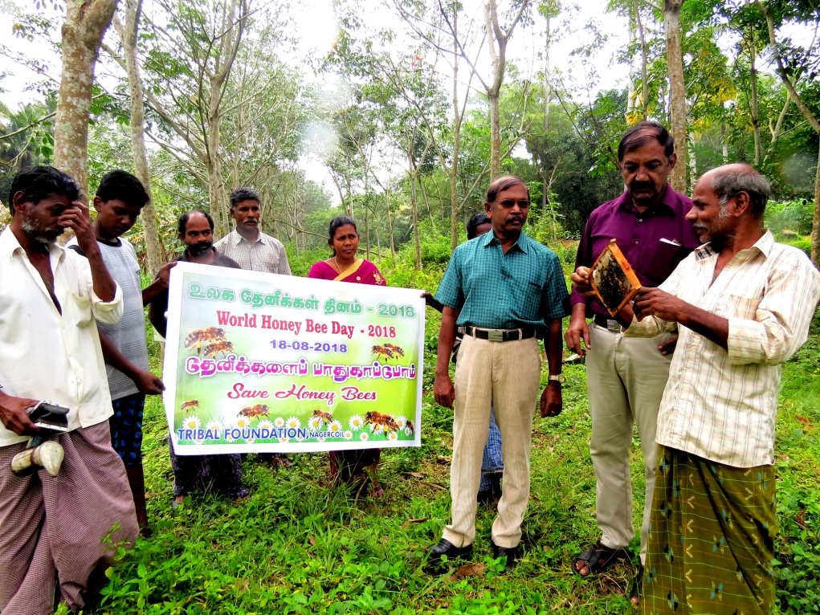

World Forest Day- Eco-exposure to Forests

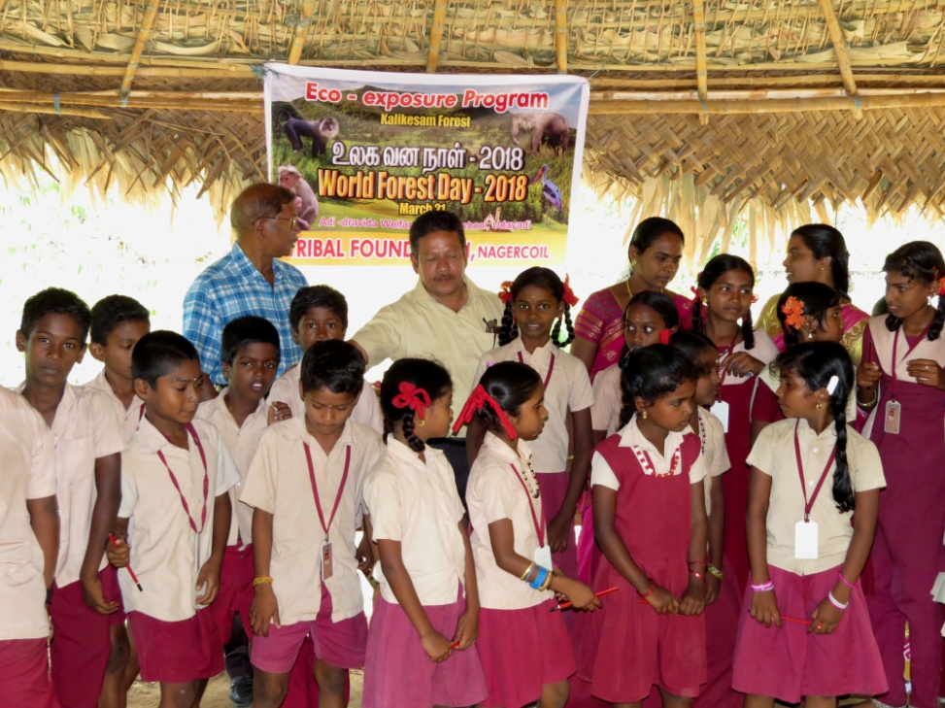

Seminar- Forest Conservation

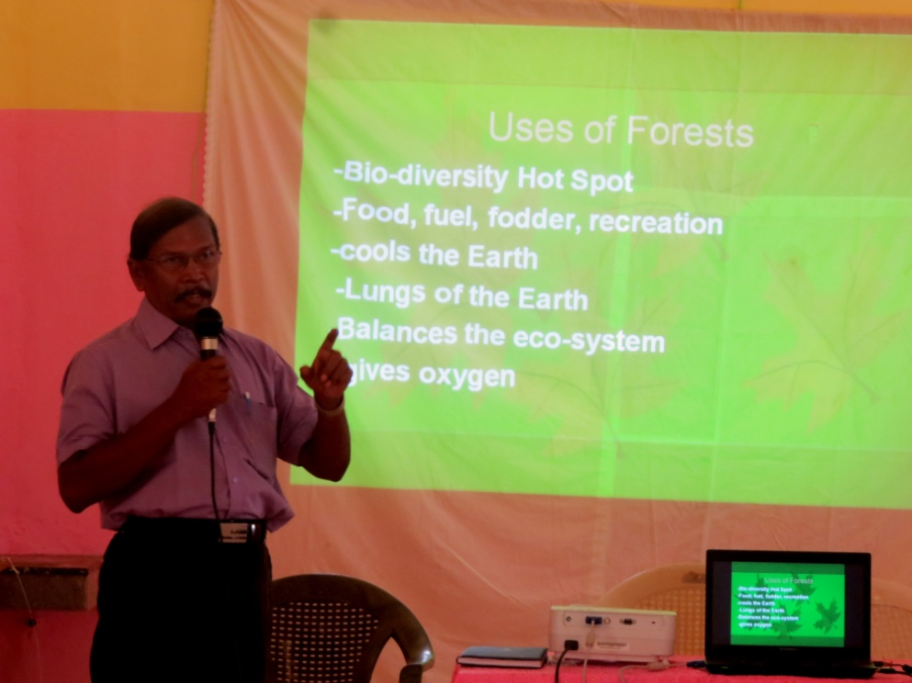

Seminar- Forest Conservation

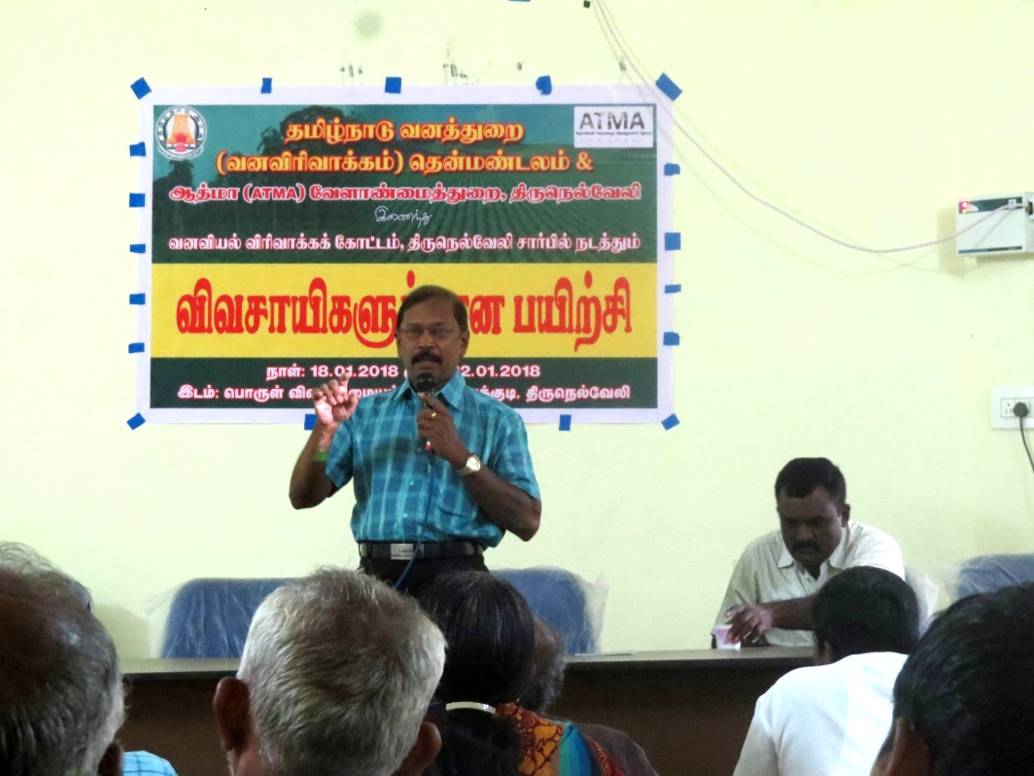

Indian National Bird- Peacock rescued

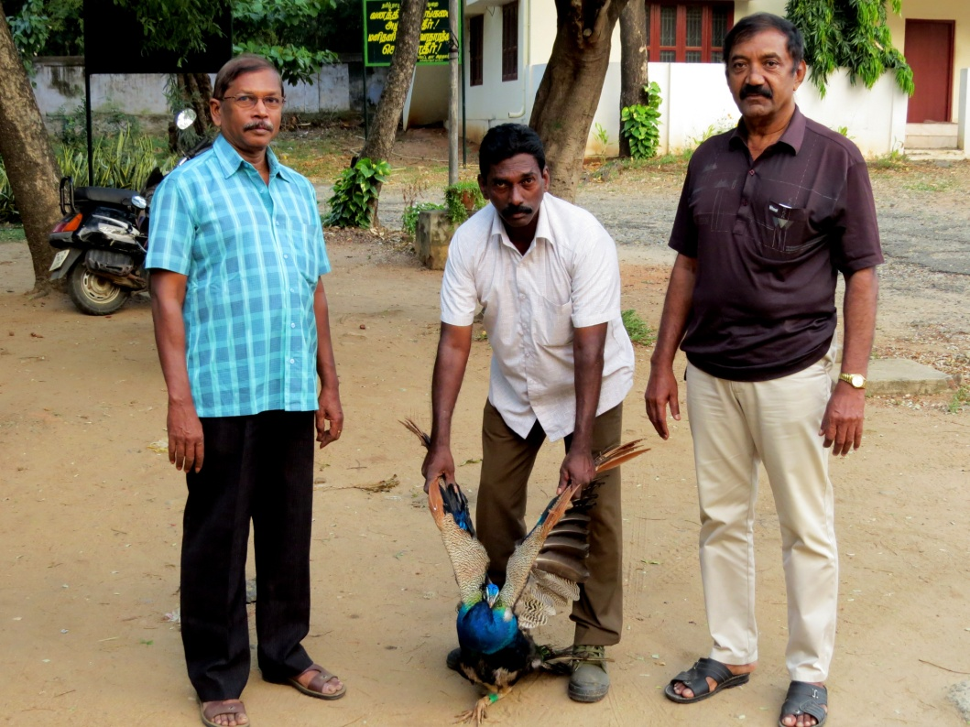

Huge Black Rat snake rescued

