World Elephant Day Awareness Meeting at School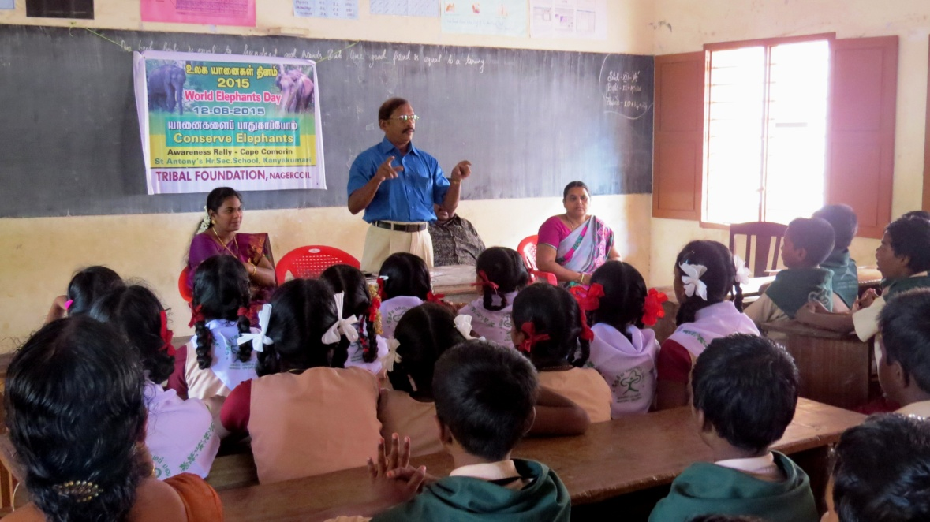

World Elephant Day Awareness Rally at Cape Comorin
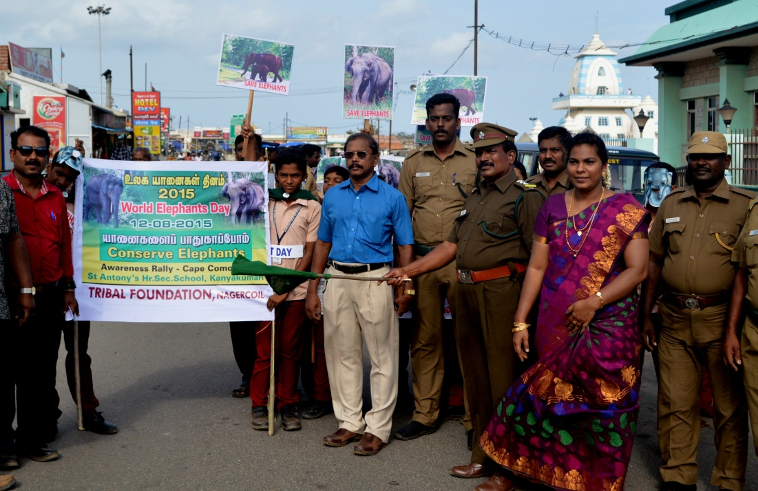

World Elephant Day Awareness Meeting at College
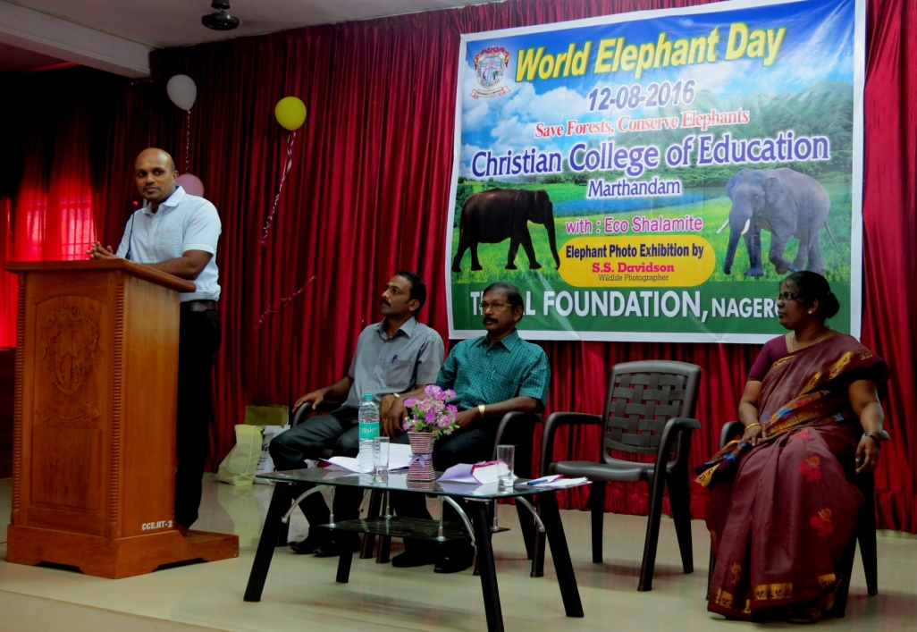

World Elephant Day Celebration with Exhibition
